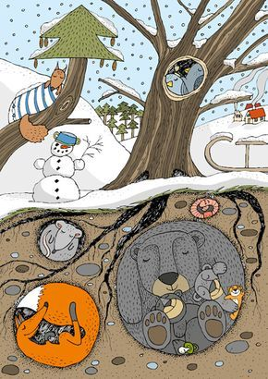
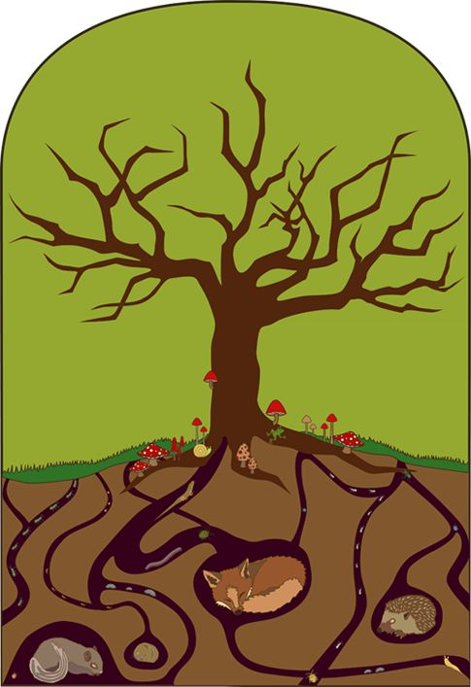

https://www.kindykids.gr/images/stories/xeimeria-narki/zwa-xeimeria-narki.pdf

