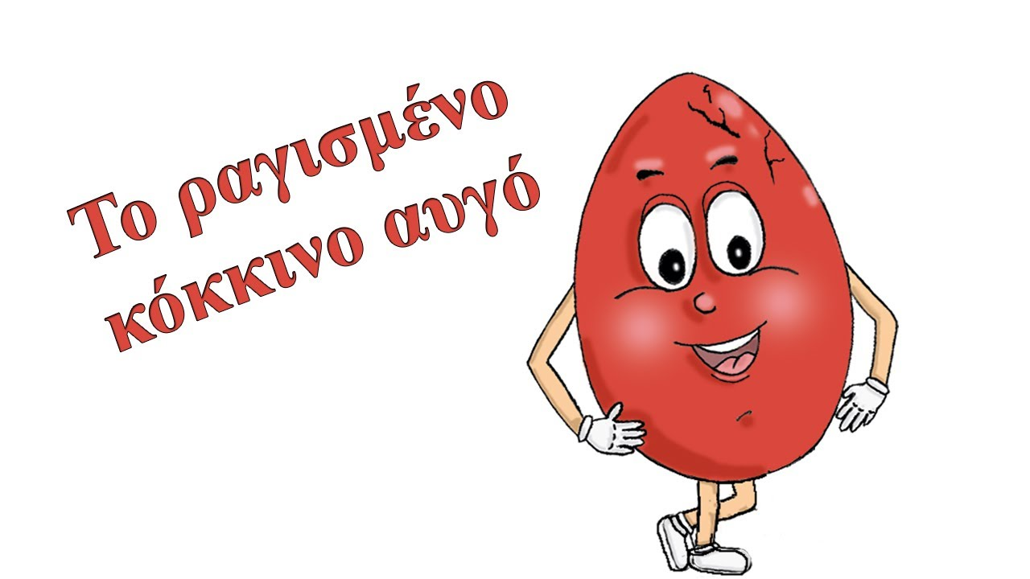

https://www.liveworksheets.com/js142954gk

