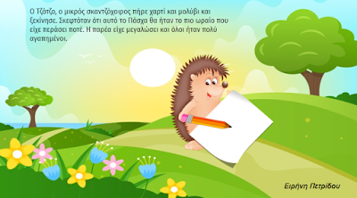
https://docs.google.com/presentation/d/1klt26jCu6Rv7k-QITRIOof6pSn-kEpngiYr3hVjlQoU/edit#slide=id.gd3646960d0_0_78

