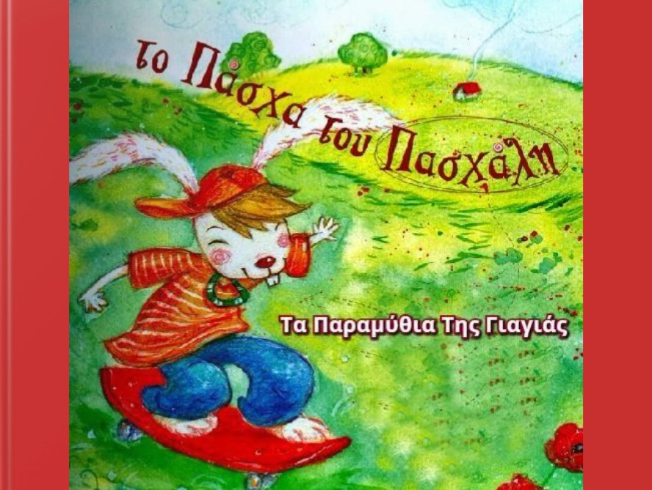

https://read.bookcreator.com/ivceVvD6qQhKC1G3nCvSXIY603U2/zmnZegnBScWdLK1OsBS91Q?fbclid=IwAR1LD3r2RqJT1mOzFfcgm6PML7E-p_t1uNFnOzrpf98_29T5GxGthVEdnQw

