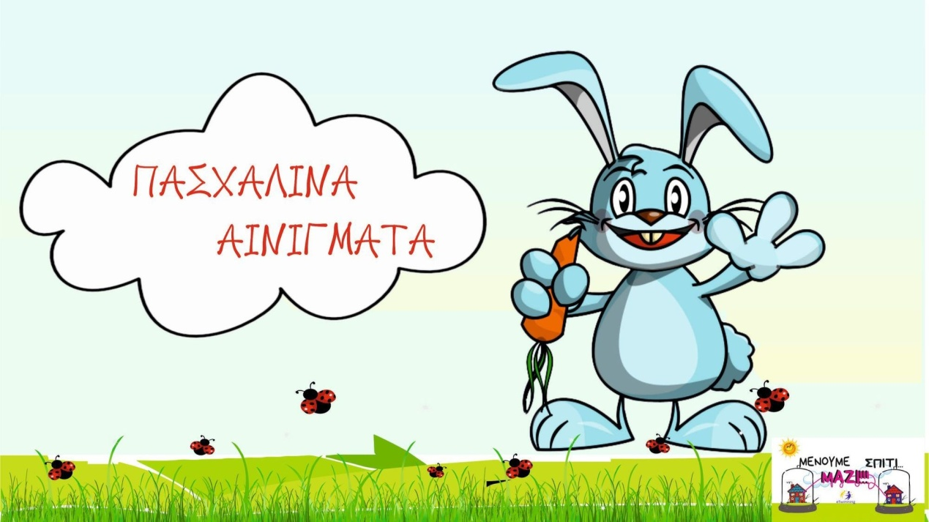

https://docs.google.com/presentation/d/1_oeThIvsVIdkZwgN0FhQEOugmdZLaG5XSes7BuyI02Q/edit?fbclid=IwAR2mFQ0PMlzdjYiknx8kezeeJuHoIjZ87dphQrLZAcSuOeAeFQ4JErf-wm4#slide=id.p

