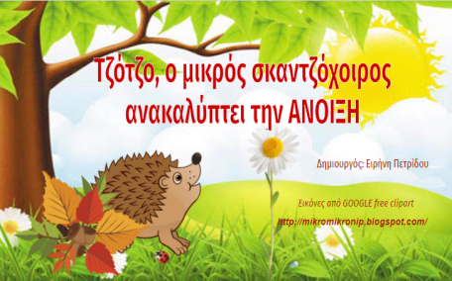
https://docs.google.com/presentation/d/1qgSrqYmLjSgn2vpnPXEBNc1o3_BM0ApDxH0PQP2aaHM/edit#slide=id.gcafaaa89a6_0_171

