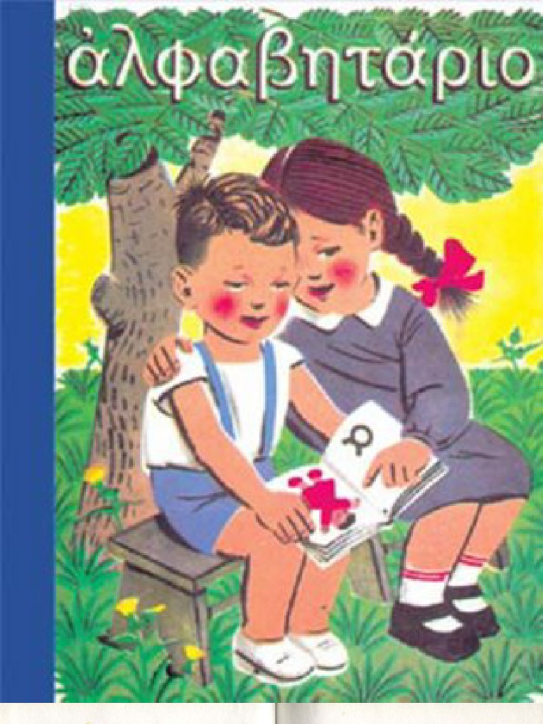
ΓΡΑΜΜΑΤΑ
http://inschool.gr/G1/LANG/LETTERS-A-026-triviaSea1-img3text6q-PRAC-G1-LANG-1606191042-tzortzisk/index.html
ΣΥΛΛΑΒΕΣ
http://inschool.gr/G1/LANG/LETTERS-A-032-syllaves-triviaUni1-text3img-PRAC-G1-LANG-1606191046-tzortzisk/index.html
http://inschool.gr/G1/LANG/LETTERS-A-034-syllaves-triviaSea1-img3text6q-PRAC-G1-LANG-1606191048-tzortzisk/index.html
ΚΕΦΑΛΑΙΑ ΠΕΖΑ
http://inschool.gr/G1/LANG/LETTERS-A-052-words-capital-HPorderBstLetters-LEARN-G1-LANG-1606191052-tzortzisk/index.html
ΦΤΙΑΧΝΩ ΛΕΞΕΙΣ
http://inschool.gr/G1/LANG/LETTERS-A-072-words-write-b-gala-HPorderBstLetters-PRAC-G1-LANG-1606191102-tzortzisk/index.html
http://inschool.gr/G1/LANG/LETTERS-A-072-words-write-c-alogo-HPorderBstLetters-PRAC-G1-LANG-1606191104-tzortzisk/index2.html
http://inschool.gr/G1/LANG/LETTERS-A-072-words-write-a-alati-HPorderBstLetters-PRAC-G1-LANG-1606191100-tzortzisk/index.html

